Tutors: Francesco Tondolo, Department of Structural, Geotechnical and Building Engineering (DISEG);
Marco Gherlone, Department of Mechanical and Aerospace Engineering (DIMEAS)

Title: Monitoring using shape sensing on reinforced concrete structures

Type: Master Thesis

Commitment: Average period of 8 months

Description: The shape sensing is a novel methodology using the inverse finite element method (iFEM). This technology is actually used in the field of research of Aerospace Engineering for control and monitoring of structural integrity. It could also be used for any other structural system.
Civil structure and infrastructure could take advantage of this because this technique does not need to know the applied loads but it only refers to a small number of devices as deformation devices from which the strain and stress field is reconstructed for the entire structure.
Structural health monitoring could be greatly improved with this approach. Structure like bridges subjected to traffic load or settlement foundation could be instrumented and analysed during their lifetime in a very efficient manner and also buildings, dams and any other structure could be monitored using iFEM.
An important issue related to r.c. structures is the non-linear behaviour due to concrete cracking, and in general plastic behaviour of materials.
The aim of this thesis is to apply, modify and specialize the shape sensing approach to the structural analysis of r.c. structures; furthermore some experimental tests in laboratory are also planned in order to check and validate the developed numerical models.

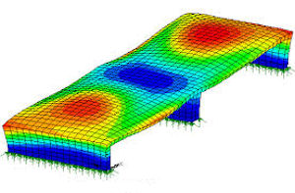 | 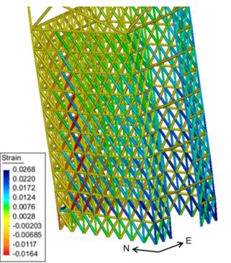
www.cedengineering.com | opensees.berkeley.edu

Necessary skills: optimum knowledge of structural mechanics, FEM methods, structural design and MATLAB programming

